Project Planning Phase
Project Planning Template (Product Backlog, Sprint Planning, Stories, Story points)
Date | 01 October 2026
Team ID | SWTID-2026-8116
Project Name | AI FitTrack API
Maximum Marks | 5 Marks

Product Backlog, Sprint Schedule, and Estimation (4 Marks)
Product backlog and sprint schedule. 23 user stories, 80 story points, 4 sprints of 20 points.
Sprint | Functional Requirement (Epic) | User Story Number | User Story / Task | Story Points | Priority | Team Members
Sprint-1 | Registration | USN-1 | As a developer, I can register on the developer portal by entering my email, password, and confirming my password. | 2 | High | Backend
Sprint-1 | Registration | USN-2 | As a developer, I will receive a verification email after registering. | 1 | High | Backend
Sprint-1 | Authentication | USN-3 | As a developer, I can log in with email and password and receive a JWT access token. | 2 | High | Backend
Sprint-1 | Authentication | USN-4 | As a developer, I can generate, rotate and revoke API keys for my application. | 3 | High | Backend
Sprint-1 | User Profile | USN-5 | As an end user, I can create my fitness profile (age, height, weight, experience level). | 3 | High | Backend
Sprint-1 | Workout Logging | USN-6 | As an end user, I can log a workout with exercises, sets, reps, weight and duration. | 5 | High | Backend
Sprint-1 | Workout Logging | USN-7 | As an end user, I can view my workout history filtered by date range. | 2 | High | Backend
Sprint-1 | Developer Experience | USN-8 | As a developer, I can read interactive OpenAPI docs and see rate-limit headers on every response. | 2 | Medium | DevOps
Sprint-2 | Nutrition Tracking | USN-9 | As an end user, I can log a meal by searching a food database. | 5 | High | Backend
Sprint-2 | Nutrition Tracking | USN-10 | As an end user, I can see a daily nutrition summary (calories, protein, carbs, fat). | 3 | High | Backend
Sprint-2 | Wearable Integration | USN-11 | As an end user, I can connect Fitbit or Google Fit through OAuth and have my activity synced. | 5 | High | Backend
Sprint-2 | Wearable Integration | USN-12 | As an end user, I can import an Apple Health export file. | 3 | Medium | Backend
Sprint-2 | Wearable Integration | USN-13 | As an end user, my sleep and heart-rate data is stored with my activity data. | 2 | Medium | Backend
Sprint-2 | Goals | USN-14 | As an end user, I can set goals (weight, strength, endurance). | 2 | High | Backend
Sprint-3 | AI Recommendations | USN-15 | As an end user, I can request a personalised weekly workout plan. | 8 | High | ML / Backend
Sprint-3 | AI Recommendations | USN-16 | As an end user, I can get AI meal suggestions that fit my daily macro targets. | 5 | High | ML / Backend
Sprint-3 | AI Recommendations | USN-17 | As an end user, my plan adjusts automatically when I skip or complete workouts. | 4 | Medium | ML
Sprint-3 | Progress Analytics | USN-18 | As an end user, I can view progress insights and trends over time. | 3 | Medium | Backend
Sprint-4 | Webhooks | USN-19 | As a developer, I can register a webhook to be notified of user milestones. | 3 | Medium | Backend
Sprint-4 | Form Feedback | USN-20 | As an end user, I can submit pose keypoints for an exercise and receive form feedback. | 5 | Low | ML
Sprint-4 | Admin Dashboard | USN-21 | As an administrator, I can view API usage, manage developer accounts and suspend keys. | 5 | Medium | Frontend
Sprint-4 | Data Privacy | USN-22 | As an end user, I can export or delete all of my data. | 4 | High | Backend
Sprint-4 | Monitoring | USN-23 | As a support engineer, I can search audit logs and receive alerts on error spikes. | 3 | Medium | DevOps
Project Tracker, Velocity & Burndown Chart: (4 Marks)
Sprint | Total Story Points | Duration | Sprint Start Date | Sprint End Date (Planned) | Story Points Completed (as on Planned End Date) | Sprint Release Date (Actual)
Sprint-1 | 20 | 6 Days | 05 Oct 2026 | 10 Oct 2026
Sprint-2 | 20 | 6 Days | 12 Oct 2026 | 17 Oct 2026
Sprint-3 | 20 | 6 Days | 19 Oct 2026 | 24 Oct 2026
Sprint-4 | 20 | 6 Days | 26 Oct 2026 | 31 Oct 2026
Completed points and actual release dates are filled in at the end of each sprint.
Velocity:
Each sprint is 6 days and the team plans 20 story points per sprint, so the target velocity is 20 points per sprint.
Average velocity (AV) per day = sprint velocity / sprint duration = 20 / 6 ≈ 3.33 story points per day.
At this rate the 80-point backlog is finished in 80 / 3.33 = 24 working days, i.e. 4 sprints.
Burndown Chart:
A burndown chart shows work left versus time. The line below is the planned (ideal) burndown; the actual line is added as each sprint closes.
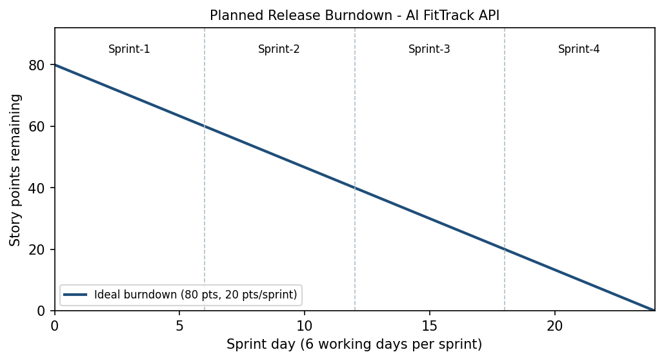
Reference:
- https://www.atlassian.com/agile/project-management
- https://www.atlassian.com/agile/tutorials/burndown-charts
- https://www.atlassian.com/agile/project-management/estimation

